**Lists**

* **Markers**
  + Create four lists (two unordered and two ordered lists)
  + The first unordered list should have circles as item markers
  + The second one (unordered) should use squares as markers
  + The third one (ordered) should use upper alphabetics
  + The last list (ordered) should use the Roman numbers
* **Image Marker/Position** 
  + Create two additional unordered lists
  + Set images as item markers for both of the lists
  + Both lists should be 200px wide, and should have a lot of text in each item
  + The markers in the second list should be inside a box

**Table**

* Create a table with five columns and 5 rows
* Table is intended to display phone specifications
* The table should be centered on the page
* Table header row should be red
* The second column should contain images whose height should be 100px
* Each cell should have top and bottom padding of 10px
* Row background color changes to yellow on hover
* Extra task: Each odd row should have gray bg coloro

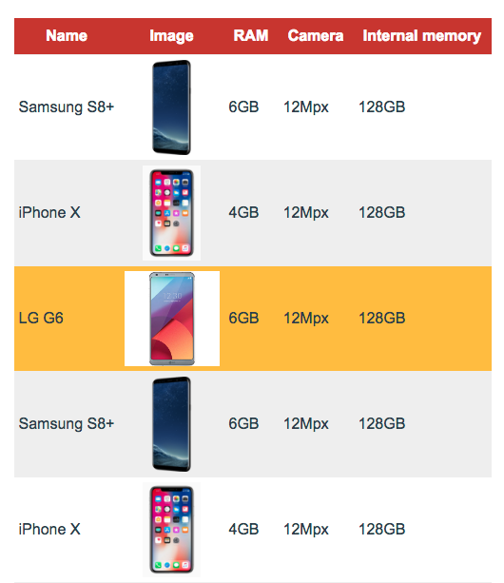

**Forms | Cursor**

**Form Elements Style**

* + Include the normalizer on page to unify default styles
  + Style the form until it looks like the form shown in the picture
* **Cursor**
  + Set the cursor to look different when hovering over different form elements
  + Use a custom image for the cursor when hovering over the submit button

